RAJALAKSHMI ENGINEERING COLLEGE

**RAJALAKSHMI NAGAR, THANDALAM – 602 105**



**LABORATORY LAB MANUAL**

**CS23331 - DESIGN AND ANALYSIS OF ALGORITHM**

**231501025**

**ASWANTH A**

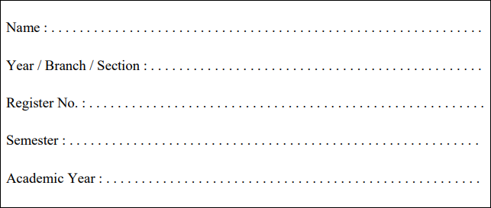

**INDEX**

**REG. NO : 231501025 NAME: ASWANTH A**

**YEAR : II YEAR BRANCH: AIML SEC: A**

|  |  |  |  |  |
| --- | --- | --- | --- | --- |
| **S.**  **NO.** | **DATE** | **TITLE** | **PAGE NO.** | **TEACHER’S SIGNATURE / REMARKS** |
| **WEEK 01 – BASIC C PROGRAMS** | | | | |
| **1.1** |  | **SWAPPING OF TWO NUMBERS** |  |  |
| **1.2** |  | **ELIGIBILITY CRITERIA** |  |  |
| **1.3** |  | **GROCERY ITEMS** |  |  |
| **1.4** |  | **BABA'S GIVING PATTERN** |  |  |
| **1.5** |  | **PUNCTUALITY INCENTIVE** |  |  |
| **1.6** |  | **DIVISIBILITY FINDER** |  |  |
| **1.7** |  | **QUOTIENT AND REMAINDER** |  |  |
| **1.8** |  | **GREATEST OF ALL NUMBERS** |  |  |
| **1.9** |  | **EVEN OR ODD** |  |  |
| **1.10** |  | **FACTORIAL OF A NUMBER** |  |  |
| **1.11** |  | **SUM OF N NATURAL NUMBERS** |  |  |
| **1.11** |  | **FIBONACCI SERIES** |  |  |
| **1.12** |  | **POWER OF INTEGERS** |  |  |
| **1.13** |  | **PRIME OR NON PRIME** |  |  |
| **1.14** |  | **REVERSE OF AN INTEGER** |  |  |
| **WEEK 02 - FINDING TIME COMPLEXITY OF ALGORITHMS** | | | | |
| **2.1** |  | **COUNTER METHOD-WHILE LOOP** |  |  |
| **2.2** |  | **COUNTER METHOD-FOR LOOP** |  |  |
| **2.3** |  | **COUNTER METHOD-FACTORS** |  |  |
| **2.4** |  | **COUNTER METHOD-FUNCTION** |  |  |
| **2.5** |  | **COUNTER METHOD-REVERSE** |  |  |

|  |  |  |  |  |
| --- | --- | --- | --- | --- |
| **WEEK 03 – DIVIDE AND CONQUER** | | | | |
| **3.1** |  | **NUMBER OF ZEROS IN AN ARRAY** |  |  |
| **3.2** |  | **MAJORITY ELEMENT** |  |  |
| **3.3** |  | **FINDING FLOOR VALUE** |  |  |
| **3.4** |  | **TWO ELEMENTS SUM TO X** |  |  |
| **3.5** |  | **IMPLEMENTATION OF QUICK SORT** |  |  |
| **WEEK 04 – GREEDY ALGORITHMS** | | | | |
| **4.1** |  | **COIN PROBLEM** |  |  |
| **4.2** |  | **COOKIES PROBLEM** |  |  |
| **4.3** |  | **BURGER PROBLEM** |  |  |
| **4.4** |  | **ARRAY SUM MAX PROBLEM** |  |  |
| **4.5** |  | **PRODCUT OF ARRAY ELEMENTS-MIN** |  |  |
| **WEEK 05 – DYNAMIC PROGRAMMING** | | | | |
| **5.1** |  | **PLAYING WITH NUMBERS** |  |  |
| **5.2** |  | **PLAYING WITH CHESSBOARD** |  |  |
| **5.3** |  | **LONGEST COMMON SUBSEQUENCE** |  |  |
| **5.4** |  | **LONGEST NON-DECREASING**  **SUBSEQUENCE** |  |  |
| **WEEK 06 – COMPETITIVE PROGRAMMING** | | | | |
| 6.1 |  | **FINDING DUPLICATES-O(N^2) TIME COMPLEXITY,O(1) SPACE COMPLEXITY** |  |  |
| 6.2 |  | **FINDING DUPLICATES-O(N) TIME**  **COMPLEXITY,O(1) SPACE COMPLEXITY** |  |  |
| 6.3 |  | **PRINT INTERSECTION OF 2 SORTED ARRAYS-O(M*N)TIME COMPLEXITY,O(1) SPACE COMPLEXITY** |  |  |
| 6.4 |  | **PRINT INTERSECTION OF 2 SORTED ARRAYS-O(M+N)TIME COMPLEXITY,O(1) SPACE COMPLEXITY** |  |  |
| 6.5 |  | **PAIR WITH DIFFERENCE-O(N^2)TIME**  **COMPLEXITY,O(1) SPACE COMPLEXITY** |  |  |
| 6.6 |  | **PAIR WITH DIFFERENCE -O(N) TIME COMPLEXITY,O(1) SPACE COMPLEXITY** |  |  |

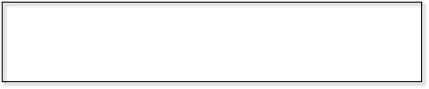

**WEEK 01 – BASIC C PROGRAMS**

**EXPERIMENT NO : 1.1 DATE :**

**REGISTER NO : 231501025 NAME : ASWANTH A**

**SWAPPING OF TWO NUMBERS**

**GIVEN TWO NUMBERS , WRITE A C PROGRAM TO SWAP THE NUMBERS.**

**FOR EXAMPLE**

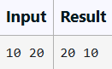

**PROGRAM**

#include<stdio.h> int main()

{

int a; int b;

int temp;

scanf("%d %d",&a,&b);

/*swapping the two numbers*/ temp=a;

a=b; b=temp;

printf("%d %d",a,b);

}

**OUTPUT**

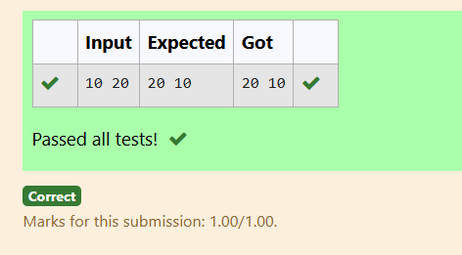

**EXPERIMENT NO : 1.2 DATE :**

**REGISTER NO : 231501025 NAME : ASWANTH A**

**ELIGIBILITY CRITERIA**

WRITE A C PROGRAM TO FIND THE ELIGIBILITY OF ADMISSION FOR A PROFESSIONAL COURSE BASED ON THE FOLLOWING CRITERIA:

MARKS IN MATHS >= 65 MARKS IN PHYSICS >= 55 MARKS IN CHEMISTRY >= 50 OR

TOTAL IN ALL THREE SUBJECTS >= 180

**SAMPLE TEST CASES : TEST CASE 1 :**

##### INPUT

70 60 80

##### OUTPUT

THE CANDIDATE IS ELIGIBLE

##### TEST CASE 2 :

**INPUT**

50 80 80

##### OUTPUT

THE CANDIDATE IS ELIGIBLE

##### TEST CASE 3 INPUT

50 60 40

##### OUTPUT

THE CANDIDATE IS NOT ELIGIBLE

**PROGRAM**

#include<stdio.h> int main()

{

int mark1; int mark2; int mark3; int total;

scanf ("%d %d %d",&mark1,&mark2,&mark3); total=mark1+mark2+mark3;

if(mark1>=65 && mark2>=55 && mark3>=50 && total>=180)

{

printf("The candidate is eligible");

}

else if(total>=180)

{

printf("The candidate is eligible");

}

else{

printf("The candidate is not eligible");

}

}

**OUTPUT**

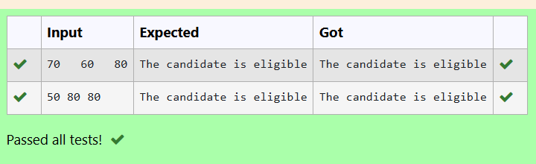

**EXPERIMENT NO : 1.3 DATE :**

**REGISTER NO : 231501025 NAME : ASWANTH A**

**GROCERY ITEMS**

MALINI GOES TO BESTSAVE HYPER MARKET TO BUY GROCERY ITEMS. BESTSAVE HYPER MARKET PROVIDES 10% DISCOUNT ON THE BILL AMOUNT B WHEN EVER THE BILL AMOUNT B IS MORE THAN RS.2000.

THE BILL AMOUNT B IS PASSED AS THE INPUT TO THE PROGRAM. THE PROGRAM MUST PRINT THE FINAL AMOUNT A PAYABLE BY MALINI.

**INPUT FORMAT:**

THE FIRST LINE DENOTES THE VALUE OF B.

**OUTPUT FORMAT:**

THE FIRST LINE CONTAINS THE VALUE OF THE FINAL PAYABLE AMOUNT A**.**

**EXAMPLE INPUT/OUTPUT 1: INPUT:**

1900

**OUTPUT:**

1900

**EXAMPLE INPUT/OUTPUT 2: INPUT:**

3000

**OUTPUT:**

2700

**PROGRAM**

#include<stdio.h> int main()

{

int b;

int discount;

scanf("%d",&b); if(b>2000)

{

discount=b*0.10;

printf("%d",b-discount);

}

else

printf("%d",b);

}

**OUTPUT**

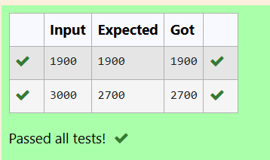

**EXPERIMENT NO : 1.4 DATE :**

**REGISTER NO : 231501025 NAME : ASWANTH A**

**BABA'S GIVING PATTERN**

BABA IS VERY KIND TO BEGGARS AND EVERY DAY BABA DONATES HALF OF THE AMOUNT HE HAS WHEN EVER A BEGGAR REQUESTS HIM. THE MONEY M LEFT IN BABA'S HAND IS PASSED AS THE INPUT AND THE NUMBER OF BEGGARS B WHO RECEIVED THE ALMS ARE PASSED AS THE INPUT. THE PROGRAM MUST PRINT THE MONEY BABA HAD IN THE BEGINNING OF THE DAY.

**INPUT FORMAT:**

THE FIRST LINE DENOTES THE VALUE OF M. THE SECOND LINE DENOTES THE VALUE OF B.

**OUTPUT FORMAT:**

THE FIRST LINE DENOTES THE VALUE OF MONEY WITH BABA IN THE BEGINNING OF THE DAY.

##### EXAMPLE INPUT/OUTPUT:

**INPUT:**

100

2

##### OUTPUT:

400

##### EXPLANATION:

Baba donated to two beggars. So when he encountered second beggar he had 100*2 = Rs.200 and when he encountered 1st he had 200*2 = Rs.400.

**PROGRAM**

#include<stdio.h> int main()

{

int money; int beggar; int amount;

scanf("%d %d",&money,&beggar);

amount=money*beggar*2; printf("%d",amount);

}

**OUTPUT**

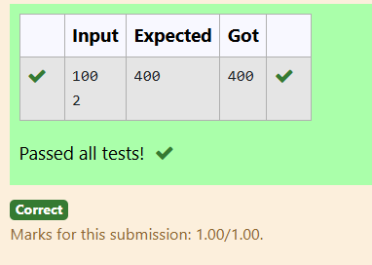

**EXPERIMENT NO : 1.5 DATE :**

**REGISTER NO : 231501025 NAME : ASWANTH A**

**PUNCTUALITY INCENTIVE**

THE CEO OF COMPANY ABC INC WANTED TO ENCOURAGE THE EMPLOYEES COMING ON TIME TO THE OFFICE. SO HE ANNOUNCED THAT FOR EVERY CONSECUTIVE DAY AN EMPLOYEE COMES ON TIME IN A WEEK (STARTING FROM MONDAY TO SATURDAY), HE WILL BE AWARDED RS.200 MORE THAN THE PREVIOUS DAY AS "PUNCTUALITY INCENTIVE". THE INCENTIVE I FOR THE STARTING DAY (IE ON MONDAY) IS PASSED AS THE INPUT TO THE PROGRAM. THE NUMBER OF DAYS N AN EMPLOYEE CAME ON TIME CONSECUTIVELY STARTING FROM MONDAY IS ALSO PASSED AS THE INPUT. THE PROGRAM MUST CALCULATE AND PRINT THE "PUNCTUALITY INCENTIVE" P OF THE EMPLOYEE.

**INPUT FORMAT:**

THE FIRST LINE DENOTES THE VALUE OF I. THE SECOND LINE DENOTES THE VALUE OF N.

**OUTPUT FORMAT:**

THE FIRST LINE DENOTES THE VALUE OF P.

**EXAMPLE INPUT/OUTPUT:**

**INPUT**:

500

3

**OUTPUT:**

2100

**EXPLANATION:**

ON MONDAY THE EMPLOYEE RECEIVES RS.500, ON TUESDAY RS.700, ON WEDNESDAY RS.900

SO TOTAL = RS.2100

**PROGRAM**

#include<stdio.h> int main()

{

int a,b,sum=0; scanf("%d",&a);

scanf("%d",&b);

for(int i=0;i<b;i++)

{

sum+=a; a=a+200;

}

printf("%d",sum);

}

**OUTPUT**

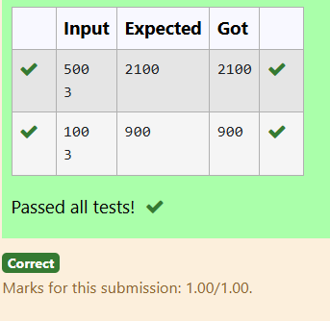

**EXPERIMENT NO : 1.6 DATE :**

**REGISTER NO : 231501025 NAME : ASWANTH A**

**DIVISIBILITY FINDER**

TWO NUMBERS M AND N ARE PASSED AS THE INPUT. A NUMBER X IS ALSO PASSED AS THE INPUT. THE PROGRAM MUST PRINT THE NUMBERS DIVISIBLE BY X FROM N TO M (INCLUSIVE OF M AND N).

**INPUT FORMAT:**

THE FIRST LINE DENOTES THE VALUE OF M THE SECOND LINE DENOTES THE VALUE OF N THE THIRD LINE DENOTES THE VALUE OF X

**OUTPUT FORMAT:**

NUMBERS DIVISIBLE BY X FROM N TO M, WITH EACH NUMBER SEPARATED BY A SPACE.

**BOUNDARY CONDITIONS:**

1 <= M <= 9999999 M < N <= 9999999 1 <= X <= 9999

**EXAMPLE INPUT/OUTPUT 1:**

INPUT:

2

40

7

OUTPUT:

35 28 21 14 7

**EXAMPLE INPUT/OUTPUT 2:**

INPUT:

66

121

11

**OUTPUT:**

121 110 99 88 77 66

**PROGRAM**

#include<stdio.h> int main()

{

int m; int n; int x;

scanf("%d %d",&m,&n);

scanf("%d",&x);

for(int i=n;i>m-1;i--)

{

if(i%x==0){

printf("%d ",i);

}

}

}

**OUTPUT**

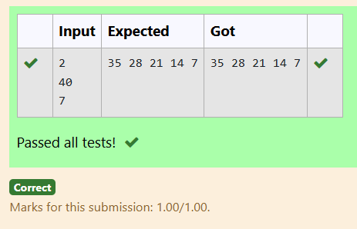

**EXPERIMENT NO : 1.7 DATE :**

**REGISTER NO : 231501025 NAME : ASWANTH A**

**QUOTIENT & REMAINDER**

**WRITE A C PROGRAM TO FIND THE QUOTIENT & REMAINDER OF GIVEN INTEGERS**

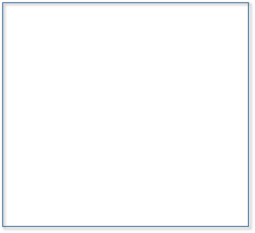**FOR EXAMPLE**

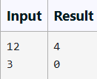

**PROGRAM**

#include<stdio.h> int main()

{

int dd; int dr;

scanf("%d",&dd);

scanf("%d",&dr); int q;

int rem; q=dd/dr;

printf("%d\n",q); rem=dd%dr;

printf("%d\n",rem);

}

**OUTPUT**

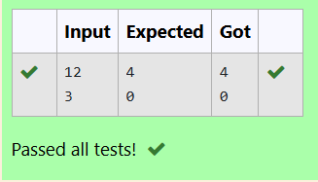

**EXPERIMENT NO : 1.8 DATE :**

**REGISTER NO : 231501025 NAME : ASWANTH A**

**GREATEST OF ALL NUMBERS**

WRITE A C PROGRAM TO FIND THE GREATEST NUMBERS OF 3 INTEGERS.

**FOR EXAMPLE**

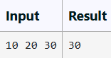

**PROGRAM**

#include<stdio.h> int main()

{

int a; int b; int c;

scanf("%d %d %d",&a,&b,&c);

if(a>b && a>c){

printf("%d",a);

}

else if(b>c && b>a){ printf("%d",b);

}

else

printf("%d",c);

}

**OUTPUT**

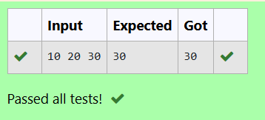

**EXPERIMENT NO : 1.9 DATE :**

**REGISTER NO : 231501025 NAME : ASWANTH A**

**EVEN OR ODD**

WRITE A C PROGRAM TO FIND THE NUMBER IS ODD OR EVEN ?

**FOR EXAMPLE**

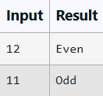

**PROGRAM**

#include<stdio.h> int main()

{

int a;

scanf("%d",&a);

if(a%2==0){

printf("Even");

}

else

printf("Odd");

}

**OUTPUT**

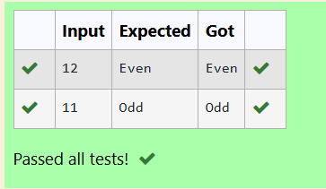

**EXPERIMENT NO : 1.10 DATE :**

**REGISTER NO : 231501025 NAME : ASWANTH A**

**FACTORIAL OF A NUMBER**

WRITE A PROGRAM TO FIND THE FACTORIAL OF A NUMBER

**FOR EXAMPLE**

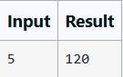

**PROGRAM**

#include<stdio.h> int main()

{

int factorial; factorial=1;

int n;

scanf("%d",&n);

for(int i=1;i<=n;i++)

{

factorial=factorial*i;

}

printf("%d",factorial);

}

**OUTPUT**

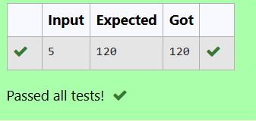

**EXPERIMENT NO : 1.11 DATE :**

**REGISTER NO : 231501025 NAME : ASWANTH A**

**SUM OF N NATURAL NUMBERS** WRITE A C PROGRAM TO FIND THE SUM OF N NATURAL NUMBERS **FOR EXAMPLE**

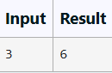

**PROGRAM**

#include<stdio.h> int main(){

int number;

scanf("%d",&number); int i;

int sum; sum=0;

for(i=number;i>=0;i--)

{

sum=sum+i;

}

printf("%d",sum);

}

**OUTPUT**

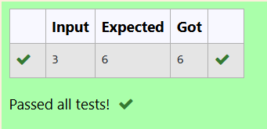

**EXPERIMENT NO : 1.12 DATE :**

**REGISTER NO : 231501025 NAME : ASWANTH A**

**FIBONACCI SERIES**

WRITE A C PROGRAM TO FIND THE NTH TERM OF FIBONACCI SERIES

**FOR EXAMPLE**

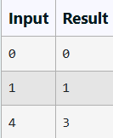

**PROGRAM**

#include<stdio.h> int main()

{

int a; int b; int c;

int sum; b=0; c=1;

sum=0;

scanf("%d",&a);

for(int i=0;i<a-1;i++){ sum=b+c;

b=c; c=sum;

}

if(a==1){

printf("1");

}else{

printf("%d",sum);

}

}

**OUTPUT**

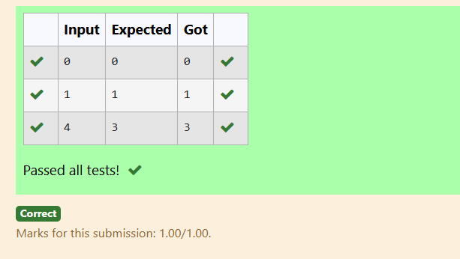

**EXPERIMENT NO : 1.13 DATE :**

**REGISTER NO : 231501025 NAME : ASWANTH A**

**POWER OF INTEGERS**

WRITE A C PROGRAM TO FIND THE POWER OF INTEGERS.

##### INPUT:

A B

##### OUTPUT:

A^B VALUE

**FOR EXAMPLE**

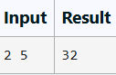

**PROGRAM**

#include<stdio.h> #include<math.h> int main()

{

int a; int b;

scanf("%d %d",&a,&b);

int power;

power=pow(a,b);

printf("%d",power);

}

**OUTPUT**

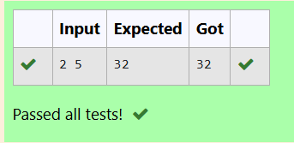

**EXPERIMENT NO : 1.14 DATE :**

**REGISTER NO : 231501025 NAME : ASWANTH A**

**PRIME OR NON PRIME**

WRITE A C PROGRAM TO FIND WHETHER NUMBER IS PRIME OR NOT?

**FOR EXAMPLE**

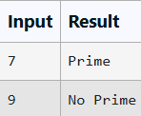

**PROGRAM**

#include<stdio.h>

int main()

{

int number;

scanf("%d",&number);

if(number%2==0){

printf("No Prime");

}

else if(number%3==0){

printf("No Prime");

}

else if(number%number==0 && number/number==1){ printf("Prime");

}

else

printf("Prime");

}

**OUTPUT**

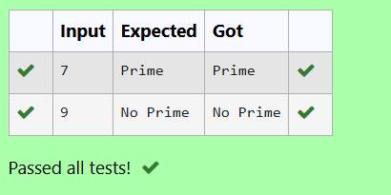

**EXPERIMENT NO : 1.15 DATE :**

**REGISTER NO : 231501025 NAME : ASWANTH A**

**REVERSE OF AN INTEGER**

WRITE A C PROGRAM TO FIND THE REVERSE OF AN INTEGER .

**PROGRAM**

#include<stdio.h> int main()

{

int n;

scanf("%d",&n); int reverse;

reverse=0; int last; last=0;

while(n!=0){ last=n%10;

reverse=reverse*10+last; n/=10;

}

printf("%d",reverse);

}

**OUTPUT**

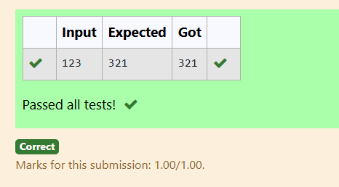



**WEEK 02 - FINDING TIME COMPLEXITY OF ALGORITHMS**

**EXPERIMENT NO : 2.1 DATE :**

**REGISTER NO : 231501025 NAME : ASWANTH A**

**COUNTER METHOD-WHILE LOOP**

**CONVERT THE FOLLOWING ALGORITHM INTO A PROGRAM AND FIND ITS TIME COMPLEXITY USING THE COUNTER METHOD.**

## void function (int n)

**{**

## int i=1; Int s=1;

**While(s<=n)**

**{**

## I++; S +=I ;

**}**

**}**

**NOTE:** NO NEED OF COUNTER INCREMENT FOR DECLARATIONS AND SCANF() AND COUNT VARIABLE PRINTF() STATEMENTS**.**

**INPUT:**

A POSITIVE INTEGER N

**OUTPUT:**

PRINT THE VALUE OF THE COUNTER VARIABLE**FOR EXAMPLE:**

|  |  |
| --- | --- |
| **INPUT** | **RESULT** |
| **9** | **12** |

**PROGRAM**

#include <stdio.h> int main(){

int count=0; int n;

scanf("%d",&n); int i=1;

count++; int s=1; count++;

while(s<=n){ count++;

i++;

count++; s+=1;

count++;

}

count++;

printf("%d",count);

}

**OUTPUT**

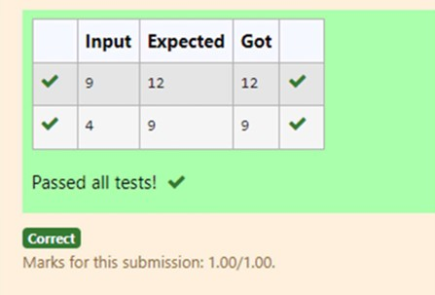

**EXPERIMENT NO : 2.2 DATE :**

**REGISTER NO : 231501025 NAME : ASWANTH A**

**COUNTER METHOD-FOR LOOP**

CONVERT THE FOLLOWING ALGORITHM INTO A PROGRAM AND FIND ITS TIME COMPLEXITY USING THE COUNTER METHOD.

**void func(int n)**

**{**

**if(n==1)**

**{**

**printf("*");**

**}**

**else**

**{**

**for(int i=1; i<=n; i++)**

**{**

**for(int j=1; j<=n; j++)**

**{**

**printf("*");**

**printf("*"); break;**

**}**

**}**

**}**

**}**

**NOTE:**

NO NEED OF COUNTER INCREMENT FOR DECLARATIONS AND SCANF() AND COUNT VARIABLE PRINTF() STATEMENTS.

**INPUT:**

A POSITIVE INTEGER N

**OUTPUT:**

PRINT THE VALUE OF THE COUNTER VARIABLE

**PROGRAM**

#include<stdio.h> int main()

{

int count=0; int n; scanf("%d",&n); if(n==1){

count++;

//printf("*");

}

//count++; else{

count++;

for(int i=1;i<=n;i++)

{

count++;

for(int j=1;j<=n;j++)

{

count++;

//printf("*"); count++;

//printf("*"); count++; break; count++;

}

count++;

}count++;

}

printf("%d",count);

}

**OUTPUT**

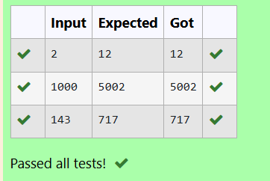

**EXPERIMENT NO : 2.3 DATE :**

**REGISTER NO : 231501025 NAME : ASWANTH A**

**COUNTER METHOD-FACTORS**

CONVERT THE FOLLOWING ALGORITHM INTO A PROGRAM AND FIND ITS TIME COMPLEXITY USING COUNTER METHOD.

# Factor(num) {

{

# for (i = 1; i <= num;++i)

{

# if (num % i== 0)

{

# printf("%d ", i);

}

}

}

**NOTE:**

NO NEED OF COUNTER INCREMENT FOR DECLARATIONS AND SCANF() AND COUNTER VARIABLE PRINTF() STATEMENT.

**INPUT:**

A POSITIVE INTEGER N

**OUTPUT:**

PRINT THE VALUE OF THE COUNTER VARIABLE

**PROGRAM**

#include<stdio.h> int main()

{

int num;

scanf("%d",&num); int count=0;

int i;

for(i=1;i<=num;i++)

{

count++;

if(num%i==0)

{

count++;

//printf("%d ",i);

//count++;

}count++;

}count++;

printf("%d",count);

}

**OUTPUT**

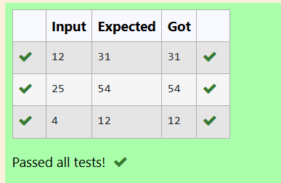

**EXPERIMENT NO : 2.4 DATE :**

**REGISTER NO : 231501025 NAME : ASWANTH A**

**COUNTER METHOD-FUNCTION**

CONVERT THE FOLLOWING ALGORITHM INTO A PROGRAM AND FIND ITS TIME COMPLEXITY USING COUNTER METHOD.

# void function(int n)

{

int c= 0;

for(int i=n/2; i<n; i++) for(int j=1; j<n; j = 2 * j)

for(int k=1; k<n; k = k * 2) c++;

}

**NOTE:**

NO NEED OF COUNTER INCREMENT FOR DECLARATIONS AND SCANF() AND COUNT VARIABLE PRINTF() STATEMENTS.

**INPUT:**

A POSITIVE INTEGER N

**OUTPUT:**

PRINT THE VALUE OF THE COUNTER VARIABLE

**PROGRAM**

#include<stdio.h> int main()

{

int n;

scanf("%d",&n); int count=0;

int c=0; count++;

for(int i=n/2;i<n;i++){ count++;

for(int j=1;j<n;j=2*j){ count++;

for(int k=1;k<n;k=k*2){ count++;

c++;

count++;

}

count++;

}

count++;

}

count++;

printf("%d",count);

}

**OUTPUT**

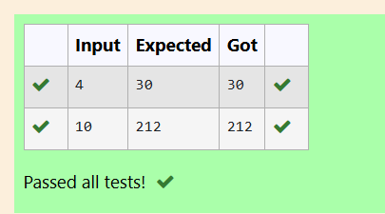

**EXPERIMENT NO : 2.5 DATE :**

**REGISTER NO : 231501025 NAME : ASWANTH A**

**COUNTER METHOD-REVERSE**

CONVERT THE FOLLOWING ALGORITHM INTO A PROGRAM AND FIND ITS TIME COMPLEXITY USING COUNTER METHOD.

#### void reverse(int n)

{

#### int rev = 0, remainder; while (n != 0)

{

#### remainder = n % 10;

rev = rev * 10 + remainder; n/= 10;

}

#### print(rev);

}

**NOTE:**

NO NEED OF COUNTER INCREMENT FOR DECLARATIONS AND SCANF() AND COUNT VARIABLE PRINTF() STATEMENTS.

**INPUT:**

A POSITIVE INTEGER N

**OUTPUT:**

PRINT THE VALUE OF THE COUNTER VARIABLE

**PROGRAM**

#include<stdio.h> int main()

{

int n;

scanf("%d",&n); int count=0;

int c=0; count++;

for(int i=n/2;i<n;i++){ count++;

for(int j=1;j<n;j=2*j){ count++;

for(int k=1;k<n;k=k*2){ count++;

c++;

count++;

}

count++;

}

count++;

}

count++;

printf("%d",count);

}

**OUTPUT**

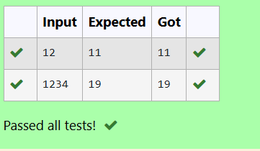



**WEEK 03 – DIVIDE AND CONQUER**

**EXPERIMENT NO : 3.1 DATE :**

**REGISTER NO : 231501025 NAME : ASWANTH A**

**NUMBER OF ZEROS IN AN ARRAY**

**PROBLEM STATEMENT**

GIVEN AN ARRAY OF 1S AND 0S THIS HAS ALL 1S FIRST FOLLOWED BY ALL 0S. AIM IS TO FIND THE NUMBER OF 0S. WRITE A PROGRAM USING DIVIDE AND CONQUER TO COUNT THE NUMBER OF ZEROES IN THE GIVEN ARRAY.

**INPUT FORMAT**

FIRST LINE CONTAINS INTEGER M – SIZE OF ARRAY

NEXT M LINES CONTAINS M NUMBERS – ELEMENTS OF AN ARRAY

**OUTPUT FORMAT**

FIRST LINE CONTAINS INTEGER – NUMBER OF ZEROES PRESENT IN THE GIVEN ARRAY.

**PROGRAM**

#include<stdio.h> int main()

{

int n; scanf("%d",&n); int arr[n];

for(int i=0;i<n;i++){ scanf("%d",&arr[i]);

}

int i;

int count=0; for(i=0;i<n;i++)

{

if(arr[i]==0)

{

count=count+1;

}

}

printf("%d",count);

}

**OUTPUT**

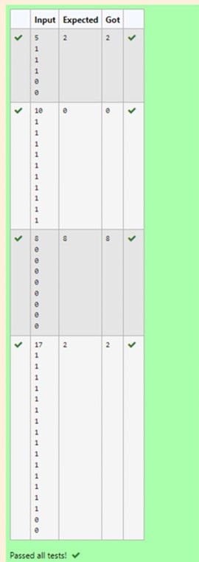

**EXPERIMENT NO : 3.2 DATE :**

**REGISTER NO : 231501025 NAME : ASWANTH A**

**MAJORITY ELEMENT**

**GIVEN AN ARRAY NUMS OF SIZE N, RETURN THE MAJORITY ELEMENT.**

THE MAJORITY ELEMENT IS THE ELEMENT THAT APPEARS MORE THAN ⌊N / 2⌋ TIMES. YOU MAY ASSUME THAT THE MAJORITY ELEMENT ALWAYS EXISTS IN THE ARRAY.

**EXAMPLE 1:**

**INPUT: NUMS =** [3,2,3]

**OUTPUT:** 3

**EXAMPLE 2:**

**INPUT: NUMS =** [2,2,1,1,1,2,2]

**OUTPUT:** 2

**CONSTRAINTS:**

N == NUMS.LENGTH 1 <= N <= 5 * 104

-231 <= NUMS[I] <= 231 - 1

**FOR EXAMPLE:**

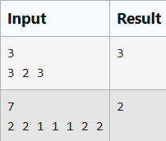

**PROGRAM**

#include<stdio.h> int main(){

int n;

scanf("%d",&n); int a[n];

for(int i=0;i<n;i++){ scanf("%d",&a[i]);

}

for(int i=0;i<n;i++){ int count=0;

for(int j=0;j<n;j++){ if(a[i]==a[j]){

count++;

}

}

if(count>n/2){

printf("%d",a[i]); break;

}

}

}

**OUTPUT**

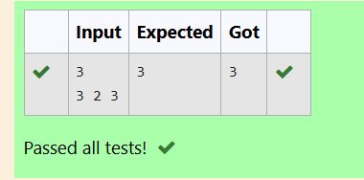

**EXPERIMENT NO : 3.3 DATE :**

#include<stdio.h> int main()

{

int n;

scanf("%d",&n); int arr[n];

for(int i=0;i<n;i++)

{

scanf("%d",&arr[i]);

}

int key=0;

scanf("%d",&key); int floor=arr[0];

for(int j=1;j<n;j++)

{

if(arr[j]>floor && arr[j]<key)

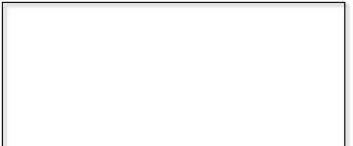

**REGISTER NO : 231501025 NAME : ASWANTH A**

**FINDING FLOOR VALUE**

**PROBLEM STATEMENT:**

GIVEN A SORTED ARRAY AND A VALUE X, THE FLOOR OF X IS THE LARGEST ELEMENT IN ARRAY SMALLER THAN OR EQUAL TO X. WRITE DIVIDE AND CONQUER ALGORITHM TO FIND FLOOR OF X.

**INPUT FORMAT**

* FIRST LINE CONTAINS INTEGER N – SIZE OF ARRAY
* NEXT N LINES CONTAINS N NUMBERS – ELEMENTS OF AN ARRAY
* LAST LINE CONTAINS INTEGER X – VALUE FOR X

**OUTPUT FORMAT**

FIRST LINE CONTAINS INTEGER – FLOOR VALUE FOR X

**PROGRAM**

floor=arr[j];

}

printf("%d",floor);

}

**OUTPUT**

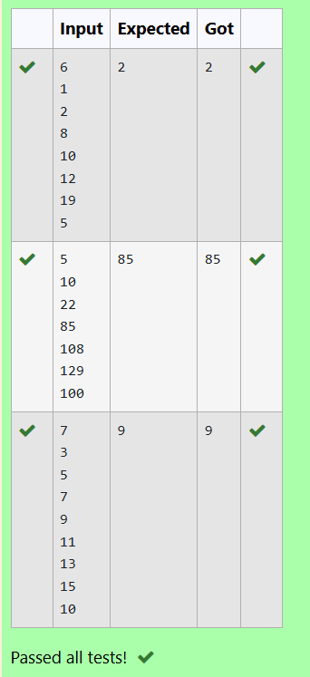

**EXPERIMENT NO : 3.4 DATE :**

#include<stdio.h> int main()

{

int n; scanf("%d",&n); int arr[n];

for(int i=0;i<n;i++){ scanf("%d",&arr[i]);

}

int i,j;

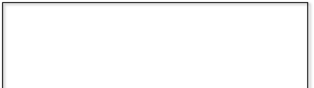

**REGISTER NO : 231501025 NAME : ASWANTH A**

**TWO ELEMENTS SUM TO X**

**PROBLEM STATEMENT:**

GIVEN A SORTED ARRAY OF INTEGERS SAY ARR[] AND A NUMBER X. WRITE A RECURSIVE PROGRAM USING DIVIDE AND CONQUER STRATEGY TO CHECK IF THERE EXIST TWO ELEMENTS IN THE ARRAY WHOSE SUM = X. IF THERE EXIST SUCH TWO ELEMENTS THEN RETURN THE NUMBERS, OTHERWISE PRINT AS “NO”.

**NOTE: WRITE A DIVIDE AND CONQUER SOLUTION**

**INPUT FORMAT**

* FIRST LINE CONTAINS INTEGER N – SIZE OF ARRAY
* NEXT N LINES CONTAINS N NUMBERS – ELEMENTS OF AN ARRAY
* LAST LINE CONTAINS INTEGER X – SUM VALUE

**OUTPUT FORMAT**

* FIRST LINE CONTAINS INTEGER – ELEMENT1
* SECOND LINE CONTAINS INTEGER – ELEMENT2 (ELEMENT 1 AND ELEMENTS 2 TOGETHER SUMS TO VALUE “X”)

**PROGRAM**

int flag; int x;

scanf("%d",&x); for(i=0;i<n;i++){

for(j=i+1;j<n;j++){ if(arr[i]+arr[j]==x){

printf("%d\n%d",arr[i],arr[j]); flag=1;

break;

}

}

}

if(flag==0) printf("No");

}

**OUTPUT**

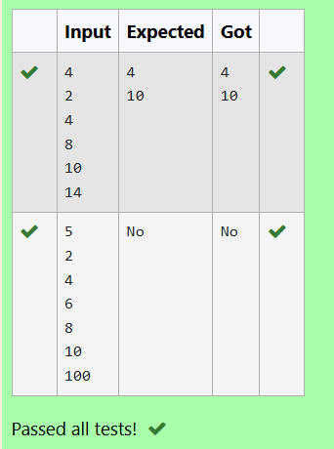

**EXPERIMENT NO : 3.5 DATE :**

#include<stdio.h> int main() {

int n; scanf("%d", &n); int arr[n];

for(int i = 0; i < n; i++) { scanf("%d", &arr[i]);

}

for(int i = 0; i < n-1; i++) {



**REGISTER NO : 231501025 NAME : ASWANTH A**

**IMPLEMENTATION OF QUICK SORT**

WRITE A PROGRAM TO IMPLEMENT THE QUICK SORT ALGORITHM

**INPUT FORMAT:**

* THE FIRST LINE CONTAINS THE NO OF ELEMENTS IN THE LIST-N
* THE NEXT N LINES CONTAIN THE ELEMENTS.

**OUTPUT:**

SORTED LIST OF ELEMENTS

**FOR EXAMPLE:**

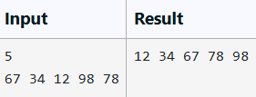

**PROGRAM**

for(int j = 0; j < n-i-1; j++)

{

if(arr[j] > arr[j+1]) { int temp = arr[j]; arr[j] = arr[j+1]; arr[j+1] = temp;

}

}

}

for(int i = 0; i < n; i++) printf("%d ", arr[i]);

}

return 0;

}

**OUTPUT**

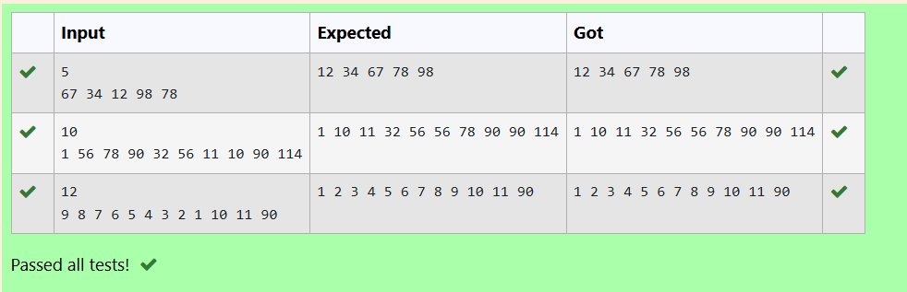



**WEEK 04 – GREEDY ALGORITHMS**

**EXPERIMENT NO : 4.1 DATE :**

**REGISTER NO : 231501025 NAME : ASWANTH A**

**COIN PROBLEM**

WRITE A PROGRAM TO TAKE VALUE V AND WE WANT TO MAKE CHANGE FOR V RS, AND WE HAVE INFINITE SUPPLY OF EACH OF THE DENOMINATIONS IN INDIAN CURRENCY, I.E., WE HAVE INFINITE SUPPLY OF { 1, 2, 5, 10, 20, 50, 100, 500, 1000} VALUED COINS/NOTES, WHAT IS THE MINIMUM NUMBER OF COINS AND/OR NOTES NEEDED TO MAKE THE CHANGE.

**INPUT FORMAT:**

TAKE AN INTEGER FROM STDIN.

**OUTPUT FORMAT:**

PRINT THE INTEGER WHICH IS CHANGE OF THE NUMBER.

**EXAMPLE INPUT :**

64

**OUTPUT:**

4

**EXPLANATON:**

WE NEED A 50 RS NOTE AND A 10 RS NOTE AND TWO 2 RUPEE COINS**.**

**PROGRAM**

#include<stdio.h> int main()

{

int value;

scanf("%d",&value);

int currency[]={1000,500,100,50,20,10,5,2,1};

int totalcurrency;

totalcurrency=sizeof(currency)/sizeof(currency[0]); int count=0;

for(int i=0;i<totalcurrency;i++)

{

if(value==0)

{

break;

}

count=count+(value/currency[i]);

value=value%currency[i];

}

printf("%d",count);

}

**OUTPUT**

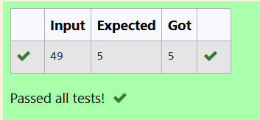

**EXPERIMENT NO : 4.2 DATE :**

**REGISTER NO : 231501025 NAME : ASWANTH A**

**COOKIES PROBLEM**

ASSUME YOU ARE AN AWESOME PARENT AND WANT TO GIVE YOUR CHILDREN SOME COOKIES. BUT, YOU SHOULD GIVE EACH CHILD AT MOST ONE COOKIE.

EACH CHILD I HAS A GREED FACTOR G[I], WHICH IS THE MINIMUM SIZE OF A COOKIE THAT THE CHILD WILL BE CONTENT WITH; AND EACH COOKIE J HAS A SIZE S[J]. IF S[J] >= G[I], WE CAN ASSIGN THE COOKIE J TO THE CHILD I, AND THE CHILD I WILL BE CONTENT. YOUR GOAL IS TO MAXIMIZE THE NUMBER OF YOUR CONTENT CHILDREN AND OUTPUT THE MAXIMUM NUMBER.

**EXAMPLE 1:**

**INPUT:**

3

1 2 3

2

1 1

**OUTPUT:**

1

**EXPLANATION:**

* YOU HAVE 3 CHILDREN AND 2 COOKIES. THE GREED FACTORS OF 3 CHILDREN ARE 1, 2, 3.
* AND EVEN THOUGH YOU HAVE 2 COOKIES, SINCE THEIR SIZE IS BOTH 1, YOU COULD ONLY MAKE THE CHILD WHOSE GREED FACTOR IS 1 CONTENT.
* YOU NEED TO OUTPUT 1.

**CONSTRAINTS:**

1 <= G.LENGTH <= 3 * 10^4

0 <= S.LENGTH <= 3 * 10^4

1 <= G[I], S[J] <= 2^31 - 1

**PROGRAM**

#include <stdio.h> int main() {

int n; scanf("%d", &n);

int greedfactor[n];

for (int i = 0; i < n; i++) { scanf("%d", &greedfactor[i]);

}

int m; scanf("%d", &m); int cookiesize[m];

for (int j = 0; j < m; j++) { scanf("%d", &cookiesize[j]);

}

for (int i = 0; i < n - 1; i++) {

for (int j = 0; j < n - i - 1; j++) {

if (greedfactor[j] > greedfactor[j + 1]) { int temp = greedfactor[j]; greedfactor[j] = greedfactor[j + 1]; greedfactor[j + 1] = temp;

}

}

}

for (int i = 0; i < m - 1; i++) {

for (int j = 0; j < m - i - 1; j++) {

if (cookiesize[j] > cookiesize[j + 1]) { int temp = cookiesize[j]; cookiesize[j] = cookiesize[j + 1]; cookiesize[j + 1] = temp;

}

}

}

int i = 0; int j = 0;

int contents = 0;

while (i < n && j < m) {

if (cookiesize[j] >= greedfactor[i]) { contents++;

i++;

} j++;

}

printf("%d\n", contents); return 0;

}

**OUTPUT**

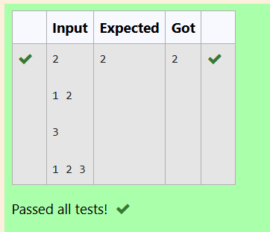

**EXPERIMENT NO : 4.3 DATE :**

**REGISTER NO : 231501025 NAME : ASWANTH A**

**BURGER PROBLEM**

A PERSON NEEDS TO EAT BURGERS. EACH BURGER CONTAINS A COUNT OF CALORIE. AFTER EATING THE BURGER, THE PERSON NEEDS TO RUN A DISTANCE TO BURN OUT HIS CALORIES. IF HE HAS EATEN I BURGERS WITH C CALORIES EACH, THEN HE HAS TO RUN AT LEAST 3I * C KILOMETERS TO BURN OUT THE CALORIES. FOR EXAMPLE, IF HE ATE 3 BURGERS WITH THE COUNT OF CALORIE IN THE ORDER: [1, 3, 2], THE KILOMETERS HE NEEDS TO RUN ARE (30 * 1) + (31 * 3) + (32 * 2) = 1 + 9 + 18 = 28.BUT THIS IS NOT THE MINIMUM, SO NEED TO TRY OUT OTHER ORDERS OF CONSUMPTION AND CHOOSE THE MINIMUM VALUE. DETERMINE THE MINIMUM DISTANCE .HE NEEDS TO RUN. NOTE: HE CAN EAT BURGER IN ANY ORDER AND USE AN EFFICIENT SORTING ALGORITHM.APPLY GREEDY APPROACH TO SOLVE THE PROBLEM.

**INPUT FORMAT**

* FIRST LINE CONTAINS THE NUMBER OF BURGERS
* SECOND LINE CONTAINS CALORIES OF EACH BURGER WHICH IS N SPACE-SEPARATE INTEGERS

**OUTPUT FORMAT**

* PRINT: MINIMUM NUMBER OF KILOMETERS NEEDED TO RUN TO BURN OUT THE CALORIES

**SAMPLE INPUT**

### 3

5 10 7

**SAMPLE OUTPUT**

### 76

**FOR EXAMPLE**

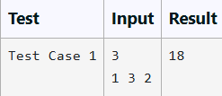

**PROGRAM**

#include<stdio.h> #include<math.h> int main(){

int n=0; scanf("%d",&n); int a[n];

for(int i=0;i<n;i++){ scanf("%d",&a[i]);

}

for(int i=0;i<n-1;i++){ for(int j=0;j<n-i-1;j++){

if(a[j]>a[j+1]){ int temp=a[j]; a[j]=a[j+1]; a[j+1]=temp;

}

}

}

int j=n-1; int sum=0;

for(int i=0;i<n;i++){ sum=sum+((pow(n,i))*a[j]); j--;

}

printf("%d",sum);

}

**OUTPUT**

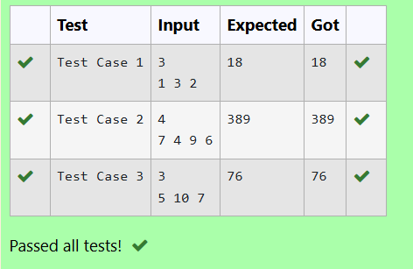

**EXPERIMENT NO : 4.4 DATE :**

#include<stdio.h> int main(){

int n;

scanf("%d",&n); int arr[n];

for(int i=0;i<n;i++)

{

scanf("%d ",&arr[i]);

}

for(int i=0;i<n-1;i++)

{

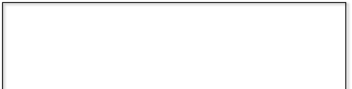

**REGISTER NO : 231501025 NAME : ASWANTH A**

**ARRAY SUM MAX PROBLEM**

GIVEN AN ARRAY OF N INTEGER, WE HAVE TO MAXIMIZE THE SUM OF ARR[I] * I, WHERE I IS THE INDEX OF THE ELEMENT (I = 0, 1, 2, ..., N).WRITE AN ALGORITHM BASED ON GREEDY TECHNIQUE WITH A COMPLEXITY O(NLOGN).

**INPUT FORMAT:**

* FIRST LINE SPECIFIES THE NUMBER OF ELEMENTS-N
* THE NEXT N LINES CONTAIN THE ARRAY ELEMENTS.

**OUTPUT FORMAT:**

MAXIMUM ARRAY SUM TO BE PRINTED.

**SAMPLE INPUT:**

### 5

2 5 3 4 0

**SAMPLE OUTPUT:**

### 40

**PROGRAM**

for(int j=0;j<n-i-1;j++){ if(arr[j]>arr[j+1]){ int temp=arr[j];

arr[j]=arr[j+1]; arr[j+1]=temp;

}

}

}

int maximum=0;

for(int i=0;i<n;i++){

maximum=maximum+(arr[i]*i);

}printf("%d\n",maximum);

}

**OUTPUT**

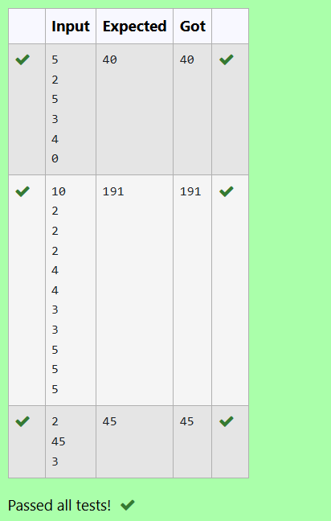

**EXPERIMENT NO : 4.5 DATE :**

#include <stdio.h> #include <stdlib.h> int main() {

int n;

scanf("%d", &n); int arrayOne[n]; int arrayTwo[n];

for (int i=0;i<n;i++) {

scanf("%d",&arrayOne[i]);

}

for (int i=0;i<n;i++) {

scanf("%d",&arrayTwo[i]);

}

for (int i=0;i<n-1;i++) {

for (int j=0;j<n-i-1;j++) {

if (arrayOne[j]>arrayOne[j+1]) { int temp = arrayOne[j];

arrayOne[j]=arrayOne[j + 1]; arrayOne[j+1]=temp;

}

}

}

for (int i=0;i<n-1;i++) {

for (int j=0;j<n-i-1;j++) {

if (arrayTwo[j]<arrayTwo[j+1]) {

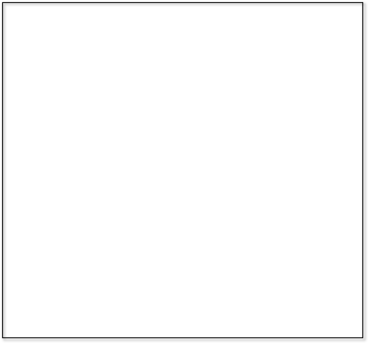

**REGISTER NO : 231501025 NAME : ASWANTH A**

**PRODCUT OF ARRAY ELEMENTS-MIN**

GIVEN TWO ARRAYS ARRAY_ONE[] AND ARRAY_TWO[] OF SAME SIZE N. WE NEED TO FIRST REARRANGE THE ARRAYS SUCH THAT THE SUM OF THE PRODUCT OF PAIRS( 1 ELEMENT FROM EACH) IS MINIMUM. THAT IS SUM (A[I] * B[I]) FOR ALL I IS MINIMUM.

**FOR EXAMPLE**

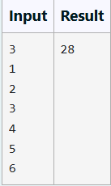

**PROGRAM**

int temp=arrayTwo[j];

arrayTwo[j]=arrayTwo[j+1]; arrayTwo[j+1]=temp;

}

}

}

int minimumsum = 0;

for (int i = 0; i < n; i++) {

minimumsum=minimumsum+arrayOne[i]*arrayTwo[i];

}

printf("%d\n", minimumsum);

}

**OUTPUT**

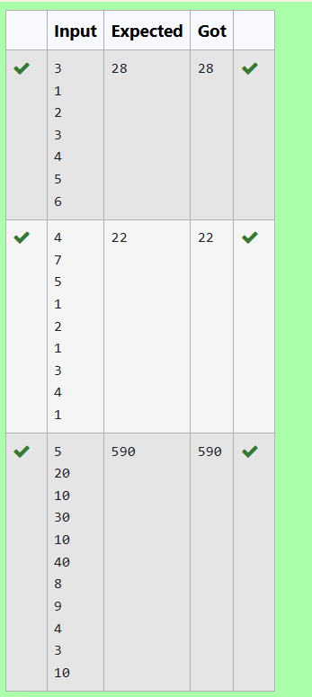



**WEEK – 05 PLAYING WITH NUMBERS**

**EXPERIMENT NO : 5.1 DATE :**

**REGISTER NO : 231501025 NAME : ASWANTH A**

**PLAYING WITH NUMBERS**

##### PLAYING WITH NUMBERS:

RAM AND SITA ARE PLAYING WITH NUMBERS BY GIVING PUZZLES TO EACH OTHER. NOW IT WAS RAM TERM, SO HE GAVE SITA A POSITIVE INTEGER ‘N’ AND TWO NUMBERS 1 AND 3. HE ASKED HER TO FIND THE POSSIBLE WAYS BY WHICH THE NUMBER N CAN BE REPRESENTED USING 1 AND 3.WRITE ANY EFFICIENT ALGORITHM TO FIND THE POSSIBLE WAYS.

##### EXAMPLE 1:

**INPUT:**

6

**OUTPUT:**

6

##### EXPLANATION:

THERE ARE 6 WAYS TO 6 REPRESENT NUMBER WITH 1 AND 3 1+1+1+1+1+1

3+3

1+1+1+3

1+1+3+1

1+3+1+1

3+1+1+1

##### INPUT FORMAT

FIRST LINE CONTAINS THE NUMBER N

##### OUTPUT FORMAT PRINT:

THE NUMBER OF POSSIBLE WAYS ‘N’ CAN BE REPRESENTED USING 1 AND 3

##### SAMPLE INPUT

6

##### SAMPLE OUTPUT

6

**PROGRAM**

#include <stdio.h> int main() {

long n;

scanf("%ld", &n); if (n < 0) {

return 0;

}

long array[n + 1]; array[0] = 1;

array[1] = 1;

array[2] = 1;

array[3] = 2;

for (long i = 4; i <= n; i++) {

array[i] = array[i - 1] + array[i - 3];

}

printf("%ld\n", array[n]); return 0;

}

**OUTPUT**

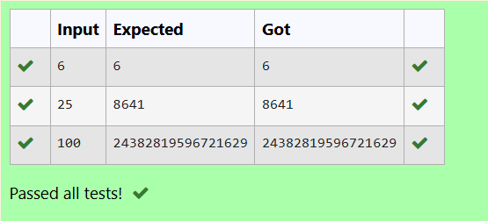

**EXPERIMENT NO : 5.2 DATE :**

**REGISTER NO : 231501025 NAME : ASWANTH A**

**PLAYING WITH CHESSBOARD PLAYING WITH CHESSBOARD:**

RAM IS GIVEN WITH AN N*N CHESSBOARD WITH EACH CELL WITH A MONETARY VALUE. RAM STANDS AT THE (0,0), THAT THE POSITION OF THE TOP LEFT WHITE ROOK. HE IS BEEN GIVEN A TASK TO REACH THE BOTTOM RIGHT BLACK ROOK POSITION (N-1, N-1) CONSTRAINED THAT HE NEEDS TO REACH THE POSITION BY TRAVELING THE MAXIMUM MONETARY PATH UNDER THE CONDITION THAT HE CAN ONLY TRAVEL ONE STEP RIGHT OR ONE STEP DOWN THE BOARD. HELP RAM TO ACHIEVE IT BY PROVIDING AN EFFICIENT DP ALGORITHM.

**EXAMPLE:**

**INPUT**

3

1 2 4

2 3 4

8 7 1

**OUTPUT:**

19

**EXPLANATION:**

TOTALLY THERE WILL BE 6 PATHS AMONG THAT THE OPTIMAL IS OPTIMAL PATH VALUE:1+2+8+7+1=19

**INPUT FORMAT**

* FIRST LINE CONTAINS THE INTEGER N
* THE NEXT N LINES CONTAIN THE N*N CHESSBOARD VALUES

**OUTPUT FORMAT**

PRINT MAXIMUM MONETARY VALUE OF THE PATH

**PROGRAM**

#include <stdio.h>

int maxMonetaryPath(int n, int board[n][n])

{

int dp[n][n];

dp[0][0] = board[0][0];

for (int j = 1; j < n; j++){

dp[0][j] = dp[0][j - 1] + board[0][j];

}

for (int i = 1; i < n; i++) {

dp[i][0] = dp[i - 1][0] + board[i][0];

}

for (int i = 1; i < n; i++) { for (int j = 1; j < n; j++) {

dp[i][j] = board[i][j] + (dp[i - 1][j] > dp[i][j - 1] ? dp[i - 1][j] : dp[i][j - 1]);

}

}

return dp[n - 1][n - 1];

}

int main() {

int n; scanf("%d", &n);

int board[n][n];

for (int i = 0; i < n; i++) { for (int j = 0; j < n; j++) {

scanf("%d", &board[i][j]);

}

}

int maxValue = maxMonetaryPath(n, board); printf("%d\n", maxValue);

return 0;

}

**OUTPUT**

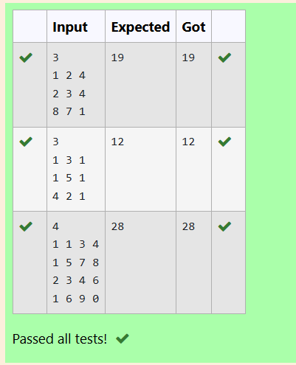

**EXPERIMENT NO : 5.3 DATE :**

**REGISTER NO : 231501025 NAME : ASWANTH A**

**LONGEST COMMON SUBSEQUENCE**

GIVEN TWO STRINGS FIND THE LENGTH OF THE COMMON LONGEST SUBSEQUENCE(NEED NOT BE CONTIGUOUS) BETWEEN THE TWO.

**EXAMPLE:**

**S1:** GGTABE

**S2:** TGATASB

|  |  |  |  |  |  |  |
| --- | --- | --- | --- | --- | --- | --- |
| S1: | A G | G | T | A | B |  |
| S2: | G X | T | X | A | Y | B |

THE LENGTH IS 4

**SOLVING IT USING DYNAMIC PROGRAMMING**

**FOR EXAMPLE:**

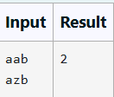

**PROGRAM**

#include <stdio.h> #include <string.h>

int longestCommonSubsequence(char *s1, char *s2) { int m = strlen(s1);

int n = strlen(s2); int dp[m + 1][n + 1];

for (int i = 0; i <= m; i++) { for (int j = 0; j <= n; j++) {

if (i == 0 || j == 0) { dp[i][j] = 0;

} else if (s1[i - 1] == s2[j - 1]) {

dp[i][j] = dp[i - 1][j - 1] + 1;

} else {

dp[i][j] = (dp[i - 1][j] > dp[i][j - 1]) ? dp[i - 1][j] :

dp[i][j - 1];

}

}

}

return dp[m][n];

}

int main() {

char s1[100], s2[100];

fgets(s1, sizeof(s1), stdin); s1[strcspn(s1, "\n")] = '\0';

fgets(s2, sizeof(s2), stdin); s2[strcspn(s2, "\n")] = '\0';

int length = longestCommonSubsequence(s1, s2); printf("%d\n", length);

return 0;

}

**OUTPUT**

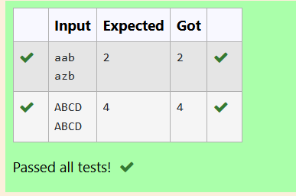

**EXPERIMENT NO : 5.4 DATE :**

#include<stdio.h>

int longseq(int arr[],int n){ int dp[n];

for(int i=0;i<n;i++){ dp[i]=1;

}

for (int i = 1; i < n; i++) { for (int j = 0; j < i; j++) {

if (arr[i] >= arr[j]) {

dp[i] = (dp[i] > dp[j] + 1) ? dp[i] : dp[j] + 1;

}

}

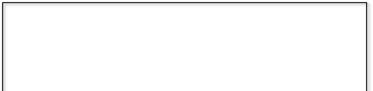

**REGISTER NO : 231501025 NAME : ASWANTH A**

**LONGEST NON-DECREASING SUBSEQUENCE**

**PROBLEM STATEMENT:**

FIND THE LENGTH OF THE LONGEST NON-DECREASING SUBSEQUENCE IN A GIVEN SEQUENCE.

**EXAMPLE:**

**INPUT:**

9

**SEQUENCE:[-1,3,4,5,2,2,2,2,3]**

**THE SUBSEQUENCE IS [-1,2,2,2,2,3]**

**OUTPUT:**

6

**PROGRAM**

}

int maximumlength=0; for(int i=0;i<n;i++){

if(dp[i]>maximumlength){ maximumlength=dp[i];

}

}

return maximumlength;

}

int main()

{

int n; scanf("%d",&n);

int arr[n];

for(int i=0;i<n;i++)

{

scanf("%d",&arr[i]);

}

int length=longseq(arr, n); printf("%d\n",length);

return 0;

}

**OUTPUT**

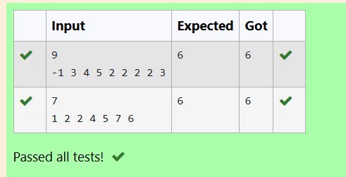



**WEEK 06 – COMPETITIVE PROGRAMMING**

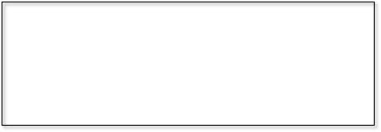**EXPERIMENT NO : 6.1 DATE : REGISTER NO : 231501025 NAME : ASWANTH A**

#include<stdio.h> int main()

{

int n,i,count; scanf("%d",&n); int arr[n];

**FINDING DUPLICATES-O(N^2) TIME COMPLEXITY,O(1) SPACE COMPLEXITY**

FIND DUPLICATE IN ARRAY.

* GIVEN A READ ONLY ARRAY OF N INTEGERS BETWEEN 1 AND N, FIND ONE NUMBER THAT REPEATS.

**INPUT FORMAT:**

* FIRST LINE - NUMBER OF ELEMENTS
* N LINES - N ELEMENTS

**OUTPUT FORMAT:**

ELEMENT X - THAT IS REPEATED

**FOR EXAMPLE:**

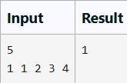

**PROGRAM**

for(i=0;i<n;i++)

{

scanf("%d",&arr[i]);

}

for(i=0;i<n;i++){ count=0;

for(int j=0;j<n;j++){ if(arr[i]==arr[j]){

count=count+1;

}

}

if(count>1){

printf("%d\n",arr[i]); break;

}

}

}

**OUTPUT**

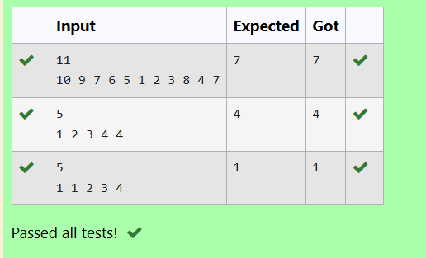

**EXPERIMENT NO : 6.2 DATE :**

#include<stdio.h> int main()

{

int n,i,count; scanf("%d",&n); int arr[n]; for(i=0;i<n;i++)

{

scanf("%d",&arr[i]);

}



**REGISTER NO : 231501025 NAME : ASWANTH A**

**FINDING DUPLICATES-O(N) TIME COMPLEXITY,O(1) SPACE COMPLEXITY**

FIND DUPLICATE IN ARRAY.

* GIVEN A READ ONLY ARRAY OF N INTEGERS BETWEEN 1 AND N, FIND ONE NUMBER THAT REPEATS.

**INPUT FORMAT:**

* FIRST LINE - NUMBER OF ELEMENTS
* N LINES - N ELEMENTS

**OUTPUT FORMAT**:

* ELEMENT X - THAT IS REPEATED

**FOR EXAMPLE:**

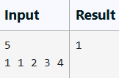

**PROGRAM**

for(i=0;i<n;i++){ count=0;

for(int j=0;j<n;j++){ if(arr[i]==arr[j]){

count=count+1;

}

}

if(count>1){

printf("%d\n",arr[i]); break;

}

}

}

**OUTPUT**

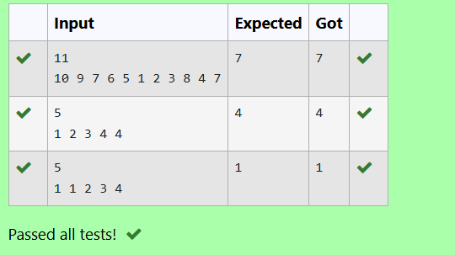

**EXPERIMENT NO : 6.3 DATE :**

**REGISTER NO : 231501025 NAME : ASWANTH A**

**PRINT INTERSECTION OF 2 SORTED ARRAYS-O(M*N)TIME COMPLEXITY,O(1) SPACE COMPLEXITY**

FIND THE INTERSECTION OF TWO SORTED ARRAYS OR IN OTHER WORDS,

* GIVEN 2 SORTED ARRAYS, FIND ALL THE ELEMENTS WHICH OCCUR IN BOTH THE ARRAYS.

**INPUT FORMAT**

· THE FIRST LINE CONTAINS T, THE NUMBER OF TEST CASES. FOLLOWING T LINES CONTAIN:

1. LINE 1 CONTAINS N1, FOLLOWED BY N1 INTEGERS OF THE FIRST ARRAY
2. LINE 2 CONTAINS N2, FOLLOWED BY N2 INTEGERS OF THE SECOND ARRAY

**OUTPUT FORMAT**

* + THE INTERSECTION OF THE ARRAYS IN A SINGLE LINE

**EXAMPLE INPUT:**

1

3 10 17 57

6 2 7 10 15 57 246

**OUTPUT:**

10 57

**INPUT:**

1

6 1 2 3 4 5 6

2 1 6

**OUTPUT:**

1 6

**FOR EXAMPLE:**

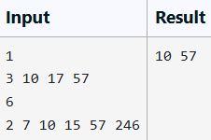

**PROGRAM**

#include <stdio.h>

void findIntersection(int arr1[], int v1, int arr2[], int v2) { int i = 0, j = 0;

while (i < v1 && j < v2) { if (arr1[i] == arr2[j]) {

printf("%d ", arr1[i]); i++;

j++;

} else if (arr1[i] < arr2[j]) { i++;

} else {

j++;

}

}

printf("\n");

}

int main() {

int T; scanf("%d", &T);

while (T--) {

int v1; scanf("%d", &v1); int arr1[v1];

for (int i = 0; i < v1; i++) { scanf("%d", &arr1[i]);

}

int v2; scanf("%d", &v2); int arr2[v2];

for (int i = 0; i < v2; i++) { scanf("%d", &arr2[i]);

}

findIntersection(arr1, v1, arr2, v2);

}

return 0;

}

**OUTPUT**

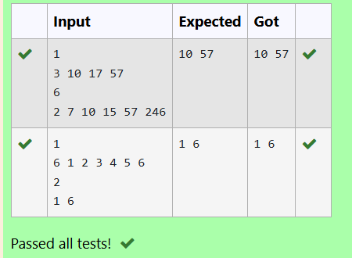

**EXPERIMENT NO : 6.4 DATE :**

**REGISTER NO : 231501025 NAME : ASWANTH A**

**PRINT INTERSECTION OF 2 SORTED ARRAYS-O(M+N)TIME COMPLEXITY,O(1) SPACE COMPLEXITY**

FIND THE INTERSECTION OF TWO SORTED ARRAYS OR IN OTHER WORDS,

* GIVEN 2 SORTED ARRAYS, FIND ALL THE ELEMENTS WHICH OCCUR IN BOTH THE ARRAYS.

**INPUT FORMAT**

· THE FIRST LINE CONTAINS T, THE NUMBER OF TEST CASES. FOLLOWING T LINES CONTAIN:

1. LINE 1 CONTAINS N1, FOLLOWED BY N1 INTEGERS OF THE FIRST ARRAY
2. LINE 2 CONTAINS N2, FOLLOWED BY N2 INTEGERS OF THE SECOND ARRAY

**OUTPUT FORMAT**

THE INTERSECTION OF THE ARRAYS IN A SINGLE LINE

**EXAMPLE INPUT:**

1

3 10 17 57

6 2 7 10 15 57 246

**OUTPUT:**

10 57

**INPUT:**

1

6 1 2 3 4 5 6

2 1 6

**OUTPUT:**

1 6

#include <stdio.h>

void findIntersection(int arr1[], int n1, int arr2[], int n2) { int i = 0, j = 0;

while (i < n1 && j < n2) {

if (arr1[i] == arr2[j]) {

printf("%d ",arr1[i]); i++;

j++;

} else if (arr1[i] < arr2[j]) { i++;

} else {

j++;

}

}

printf("\n");

}

int main() {

int T;

scanf("%d", &T);

while (T--) {

int n1;

scanf("%d", &n1); int arr1[n1];

for (int i = 0; i < n1; i++) { scanf("%d", &arr1[i]);

}

int n2;

scanf("%d", &n2); int arr2[n2];

for (int i = 0; i < n2; i++) { scanf("%d", &arr2[i]);

}

findIntersection(arr1, n1, arr2, n2);

}

return 0;

}

**OUTPUT**

**FOR EXAMPLE:**

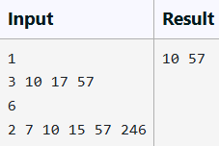

**PROGRAM**

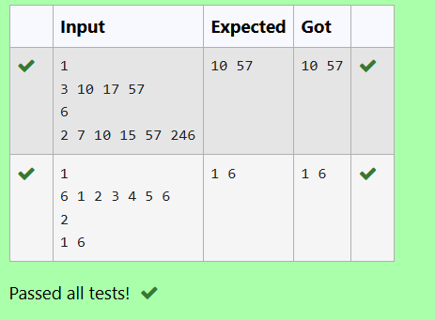

**EXPERIMENT NO : 6.5 DATE :**

#include<stdio.h> int main()

{

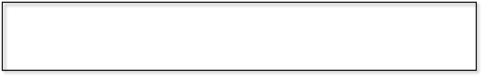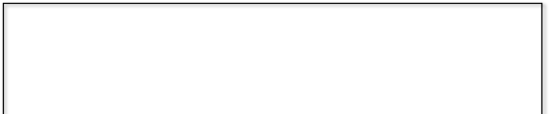

**REGISTER NO : 231501025 NAME : ASWANTH A**

**PAIR WITH DIFFERENCE-O(N^2)TIME COMPLEXITY,O(1) SPACE COMPLEXITY**

GIVEN AN ARRAY A OF SORTED INTEGERS AND ANOTHER NON NEGATIVE INTEGER K, FIND IF THERE EXISTS 2 INDICES I AND J SUCH THAT A[J] - A[I] = K, I != J.

##### INPUT FORMAT:

* FIRST LINE N - NUMBER OF ELEMENTS IN AN ARRAY
* NEXT N LINES - N ELEMENTS IN THE ARRAY
* K - NON - NEGATIVE INTEGER

**OUTPUT FORMAT:**

* 1 - IF PAIR EXISTS
* 0 - IF NO PAIR EXISTS

##### EXPLANATION FOR THE GIVEN SAMPLE TESTCASE:

YES AS 5 - 1 = 4

SO RETURN 1.

**FOR EXAMPLE**

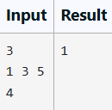

**PROGRAM**

int n; scanf("%d",&n); int array[n];

for(int i=0;i<n;i++)

{

scanf("%d",&array[i]);

}

int d; scanf("%d",&d); int count=0;

for(int i=0;i<n;i++){ for(int j=0;j<n;j++){

if(i!=j){

if(array[j]-array[i]==d){ count=count+1;

}

}

}

}

if(count==0){

printf("0");

}else printf("1");

}

**OUTPUT**

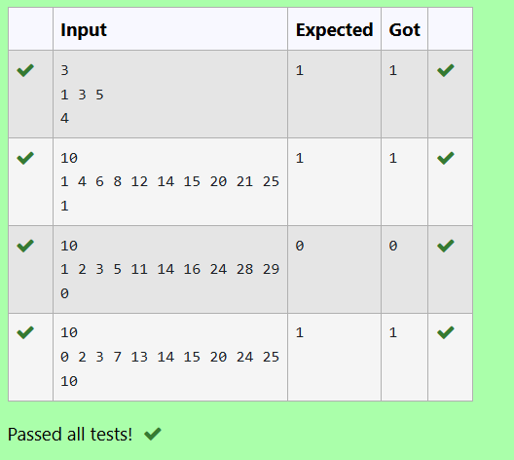

**EXPERIMENT NO : 6.6 DATE :**

**REGISTER NO : 231501025 NAME : ASWANTH A**

**PAIR WITH DIFFERENCE -O(N) TIME COMPLEXITY,O(1) SPACE COMPLEXITY**

GIVEN AN ARRAY A OF SORTED INTEGERS AND ANOTHER NON NEGATIVE INTEGER K, FIND IF THERE EXISTS 2 INDICES I AND J SUCH THAT A[J] - A[I] = K, I != J.

**INPUT FORMAT:**

* FIRST LINE N - NUMBER OF ELEMENTS IN AN ARRAY
* NEXT N LINES - N ELEMENTS IN THE ARRAY
* K - NON - NEGATIVE INTEGER

**OUTPUT FORMAT**

* 1 - IF PAIR EXISTS
* 0 - IF NO PAIR EXISTS

**EXPLANATION FOR THE GIVEN SAMPLE TESTCASE**: YES AS 5 - 1 = 4

SO RETURN 1.

**FOR EXAMPLE**

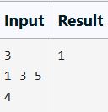

**PROGRAM**

#include<stdio.h> int main()

{

int n; scanf("%d",&n);

int array[n]; for(int i=0;i<n;i++)

{

scanf("%d",&array[i]);

}

int d; scanf("%d",&d); int count=0;

for(int i=0;i<n;i++){ for(int j=0;j<n;j++){

if(i!=j){

if(array[j]-array[i]==d){

count=count+1;

}

}

}

}

if(count==0)

{

printf("0");

}

else

printf("1");

}

**OUTPUT**

